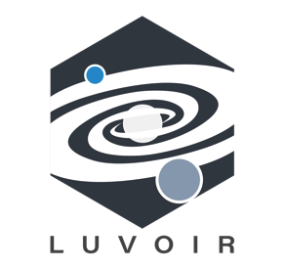

Additional LUVOIR Science Case
Please limit to 2 – 3 total pages.
Email document to LUVOIR.Science@gmail.com for inclusion in “Additional Science Cases” appendix of LUVOIR Interim Report.

YOUR TITLE HERE

AUTHORS
Jamie Doe (Acme University), others …

INTRODUCTION
Science motivation and background text goes here. Figures encouraged.

THE ROLE OF LUVOIR
Explain why this science case needs LUVOIR.

THE SCIENCE PROGRAM
Please describe the desired observations as best you can.

Give wavelength ranges, source brightnesses, and LUVOIR instrument(s) to be used. Further details on instrument characteristics can be found at https://asd.gsfc.nasa.gov/luvoir/design/.

If possible, include exposure time estimates. LUVOIR science simulation tools are available at https://asd.gsfc.nasa.gov/luvoir/tools/.

Program at a Glance
Science goal: 1 – 2 sentence description of science goal.
Program details: Briefly describe the observing program (e.g. kind of observations, targets, etc.).
Instrument(s) + configuration(s): List all needed instruments and configurations (e.g. imaging or spectroscopy, other modes, etc.).
Key observation requirements: Give key observation requirements (e.g. wavelength range, spectral resolution, signal-to-noise, contrast, photometric or astrometric precision, etc.).

REFERENCES
ApJ style, please.

